MiWay Route Efficiency Analysis
GTFS-Based Route Performance Ranking and Advocacy Priority Framework
Prepared for | MiWay Route Improvement Advocacy
Dataset | MiWay GTFS scheduled service feed; valid May 1, 2026, to June 28, 2026
Representative day | Tuesday, May 5, 2026
Analysis scope | Scheduled service, route geometry, speed, frequency, and route-level scoring
Notebooks | 01 GTFS Exploration | 02 Geometry | 03 Speed | 04 Frequency | 05 Final Ranking

This analysis converts MiWay's scheduled GTFS feed into a transparent route efficiency ranking and an advocacy priority list. The strongest routes combine high scheduled speed, frequent service, long service span, and balanced bidirectional service. The priority list highlights routes where improvement could matter because the route has meaningful service volume but weaker efficiency indicators.

66  Routes analyzed | 5,507  Weekday trips | 52  All-day routes | 17- 84  Score range

1. Executive Summary
The project analysed MiWay scheduled service using a GTFS feed valid from May 1 to June 28, 2026. Tuesday, May 5, 2026, was used as the representative service day to avoid mixing weekday and weekend patterns.

Across 66 active routes, the final route efficiency score ranges from 17.46 to 84.14, with a median score of 52.27. The system-level average scheduled speed is 22.12 km/h, and the median route-level headway is 23.75 minutes.

The highest-scoring routes are not simply those with the most trips. They tend to combine speed, all-day coverage, frequent service, and balanced bidirectional service. The advocacy priority lens surfaces routes that may deserve operational attention: substantial service volume with weaker efficiency indicators.

Important: This ranking should be treated as a screening tool. It does not replace ridership, on-time performance, crowding, equity, or rider experience data. A low score is a starting point for investigation, not evidence that a route should be cut.

2. Data Source and Pipeline
The analysis starts from MiWay's standard GTFS feed. GTFS provides a standardized scheduled-service model: routes, trips, stops, stop times, service calendars, and route shapes.
Notebook | Focus | Key Output
01 | GTFS exploration & weekday selection | Active trip subset for Tuesday, May 5, 2026
02 | Route geometry & stop metrics | Path length, directness ratio, stops per km
03 | Scheduled speed & travel time | Trip duration, distance, avg. scheduled speed
04 | Frequency & service availability | Headways, service span, directional balance
05 | Final efficiency ranking | Component scores, final ranks, advocacy scores

Each notebook produces route-level outputs that feed the next stage. The final scoring notebook joins geometry, speed, and service metrics into a single comparable index.

3. Scoring Methodology

3.1 Component Scores
Each metric is converted to a 0-100 percentile score by ranking routes against each other. For metrics where higher is better, the best route gets the highest score. For metrics where lower is better (headway, stop density), the direction is reversed. Missing values receive a neutral score of 50 so they do not dominate the final ranking.
Component | Weight | Interpretation
Scheduled speed | 25% | Higher average scheduled speed scores better.
Frequency | 25% | Lower median headway and higher trip volume score better.
Service span | 15% | Longer daily span from first to last departure scores better.
Route directness | 15% | More direct (non-loop) route geometry scores better.
Stop-spacing | 10% | Fewer stops per km scores better as an operating efficiency signal.
Directional balance | 10% | More even service between directions scores better.

Final efficiency score formula:
= 0.25(speed) + 0.25(frequency) + 0.15(service span) + 0.15(directness) + 0.10(stop spacing) + 0.10(directional balance)

3.2 Frequency Sub-score
Frequency combines median headway (weighted 70%) and total scheduled trips (weighted 30%). This prevents limited special-purpose routes from ranking highly merely because a few consecutive trips happen to be close together.

3.3 Loop and Circulator Routes
Routes whose endpoint straight-line distance is below 1 km are flagged as loop/circulator routes. Directness can be mathematically misleading for these routes, so they receive a neutral directness score of 50 rather than a penalized score.

Stop-spacing efficiency is an operating efficiency signal, not a service quality verdict. More stops per km can slow a route but stops also provide access. Any stop-consolidation recommendation requires a separate equity and accessibility review.

4. Score Bands and System Distribution
The score bands show that MiWay's scheduled performance is unevenly distributed across the network.
Band | Score Range | Route Count
Very High | Above 85 | 0
High | 70 - 85 | 7
Moderate | 55 - 70 | 22
Low | 40 - 55 | 17
Very Low | Below 40 | 20

No routes fall in the very high band. Seven routes achieve a high score, with 22 in the moderate range. The bottom 37 routes split between low and very low, suggesting meaningful headroom for network-wide improvement.

5. Final Route Efficiency Ranking – Top 10
The routes below have the highest final efficiency scores. They generally combine strong scheduled speed, frequent all-day service, and balanced bidirectional coverage.
Rank | Route | Name | Score | Trips | Speed (km/h) | Headway (min)
1 | 11 | Westwood | 84.14 | 172 | 35.64 | 15.00
2 | 35 | Eglinton | 77.54 | 159 | 24.61 | 15.00
3 | 1 | Dundas | 74.65 | 172 | 21.84 | 15.00
4 | 109 | Meadowvale Express | 72.72 | 162 | 35.02 | 15.00
5 | 42 | Derry | 72.30 | 171 | 22.33 | 15.00
6 | 66 | McLaughlin | 71.17 | 202 | 20.97 | 12.00
7 | 110 | University Express | 71.15 | 118 | 31.64 | 21.00
8 | 61 | Mavis | 69.75 | 189 | 21.32 | 14.00
9 | 107 | Malton Express | 69.57 | 147 | 26.25 | 15.00
10 | 101 | Dundas Express | 68.90 | 137 | 21.46 | 15.00

Route 11 Westwood leads with a score of 84.14, driven by the highest scheduled speed in the network (35.64 km/h), 15-minute headways, and 172 weekday trips. Route 109 Meadowvale Express is the second-fastest route (35.02 km/h), reflecting its express stop pattern.

6. Advocacy Priority Routes

6.1 How the Priority Score Works
The advocacy priority score is intentionally separate from the efficiency rank. It prioritizes routes with weaker efficiency scores and meaningful service volume, because improvements on those routes may affect more riders.

Priority score formula:
= 0.60 × (100 - efficiency score) + 0.40 × service importance score
where service importance is the route's percentile rank by scheduled weekday trips.

6.2 Top 10 Priority Routes

Priority | Route | Name | Priority Score | Efficiency | Trips
1 | 28 | Confederation | 68.44 | 37.96 | 129
2 | 6 | Credit Woodlands | 65.01 | 29.03 | 93
3 | 10 | Bristol | 64.36 | 36.16 | 102
4 | 2 | Hurontario | 64.02 | 59.96 | 232
5 | 8 | Cawthra | 62.99 | 26.33 | 71
6 | 3 | Bloor | 60.81 | 62.28 | 180
7 | 4 | North Service Road | 60.37 | 24.64 | 55
8 | 31 | Ogden | 57.42 | 45.71 | 100
9 | 30 | Rexdale | 57.28 | 23.73 | 48
10 | 61 | Mavis | 56.94 | 69.75 | 189

The highest-priority review candidates are not necessarily the worst routes - they are routes where the schedule suggests an advocacy conversation could be productive: speed may be low, headways long, stop density high, or directness weak, while the route still carries substantial scheduled service.

Routes 2 (Hurontario), 3 (Bloor), and 61 (Mavis) appear in the advocacy table despite moderate or high efficiency scores because their very high trip volume elevates their service importance, making improvements there more impactful network-wide.

7. Key Findings
- Service availability is broad but uneven. The feed contains 5,507 scheduled weekday trips across 66 active routes; 52 routes meet the all-day service flag.
- Scheduled speed varies sharply. Route-level average speed ranges from 14.95 km/h to 38.17 km/h, a 2.5× spread across the network.
- Frequency is not evenly distributed. The median route headway is 23.75 minutes, but some routes have median headways above 40 minutes.
- Several important corridors, Confederation, Credit Woodlands, Bristol, Hurontario, Cawthra, Bloor, and North Service Road, appear in the advocacy priority lens.
- School routes and special-purpose routes (e.g., Stephen Lewis SS, Streetsville SS) rank low by design. They should be interpreted separately from all-day grid routes.
- No routes currently achieve a Very High (above 85) efficiency score, suggesting network-wide opportunities for improvement.

8. Advocacy Implications
For transit and housing advocacy, the most useful conclusion is not only which route ranks first. The stronger question is where better service would unlock access to housing, campus, jobs, groceries, and late-day travel.
- Use the priority list to identify candidate corridors for deeper public-facing analysis, especially routes with high trip volume and weak efficiency indicators.
- Request ridership, crowding, on-time performance, pass-up, and stop-level boarding data from MiWay and the City of Mississauga to compare scheduled efficiency with lived rider experience.
- Pair route efficiency results with housing density, student housing locations, major employment areas, and late-night travel needs.
- Evaluate whether priority routes need bus priority infrastructure, stop consolidation, branch simplification, schedule restructuring, or better transfer coordination.
- Separate school-special and limited-purpose routes when communicating results publicly their service design goals differ from all-day local routes.
- Consider equity implications before any stop-spacing or frequency recommendations, particularly for routes serving lower-income and transit-dependent communities.

9. Possible Next Steps (If I decide to dig deeper into this analysis)
- Build a sensitivity analysis comparing alternate scoring weights for example, a rider-access-weighted score versus an operating-efficiency-weighted score.
- Add weekend notebooks for Saturday and Sunday to separate commuter, student, retail, and shift-worker travel patterns.
- Compare scheduled speed with real-time GPS or AVL data if vehicle location or historical performance feeds become available from MiWay.
- Produce a short public brief (3-5 pages) with corridor-specific policy asks aimed at City of Mississauga and MiWay decision-makers.
- Revisit the scoring weights with community stakeholders before using the index for formal policy recommendations.

10. Limitations
- The analysis uses scheduled GTFS data only not real-time vehicle movement, actual traffic conditions, or operator behaviour.
- The ranking does not include ridership, crowding, fare equity, physical accessibility barriers, safety, or on-time reliability.
- A single representative weekday keeps the project internally consistent, but weekend and seasonal patterns should be studied separately.
- The final score depends on chosen component weights. Weights should be sensitivity-tested before formal policy use.
- Lower stop density can improve scheduled speed but may harm riders with mobility constraints or those facing longer walks to stops. Any stop-spacing recommendation requires an equity review.
- Loop, school, and limited-purpose routes require separate interpretation because their design goals differ from all-day grid routes.

Figure 1 — MiWay Route Efficiency Score
Graduated colour by final efficiency score (Natural Breaks, 5 classes) — Dark Red = Low, Dark Green = High
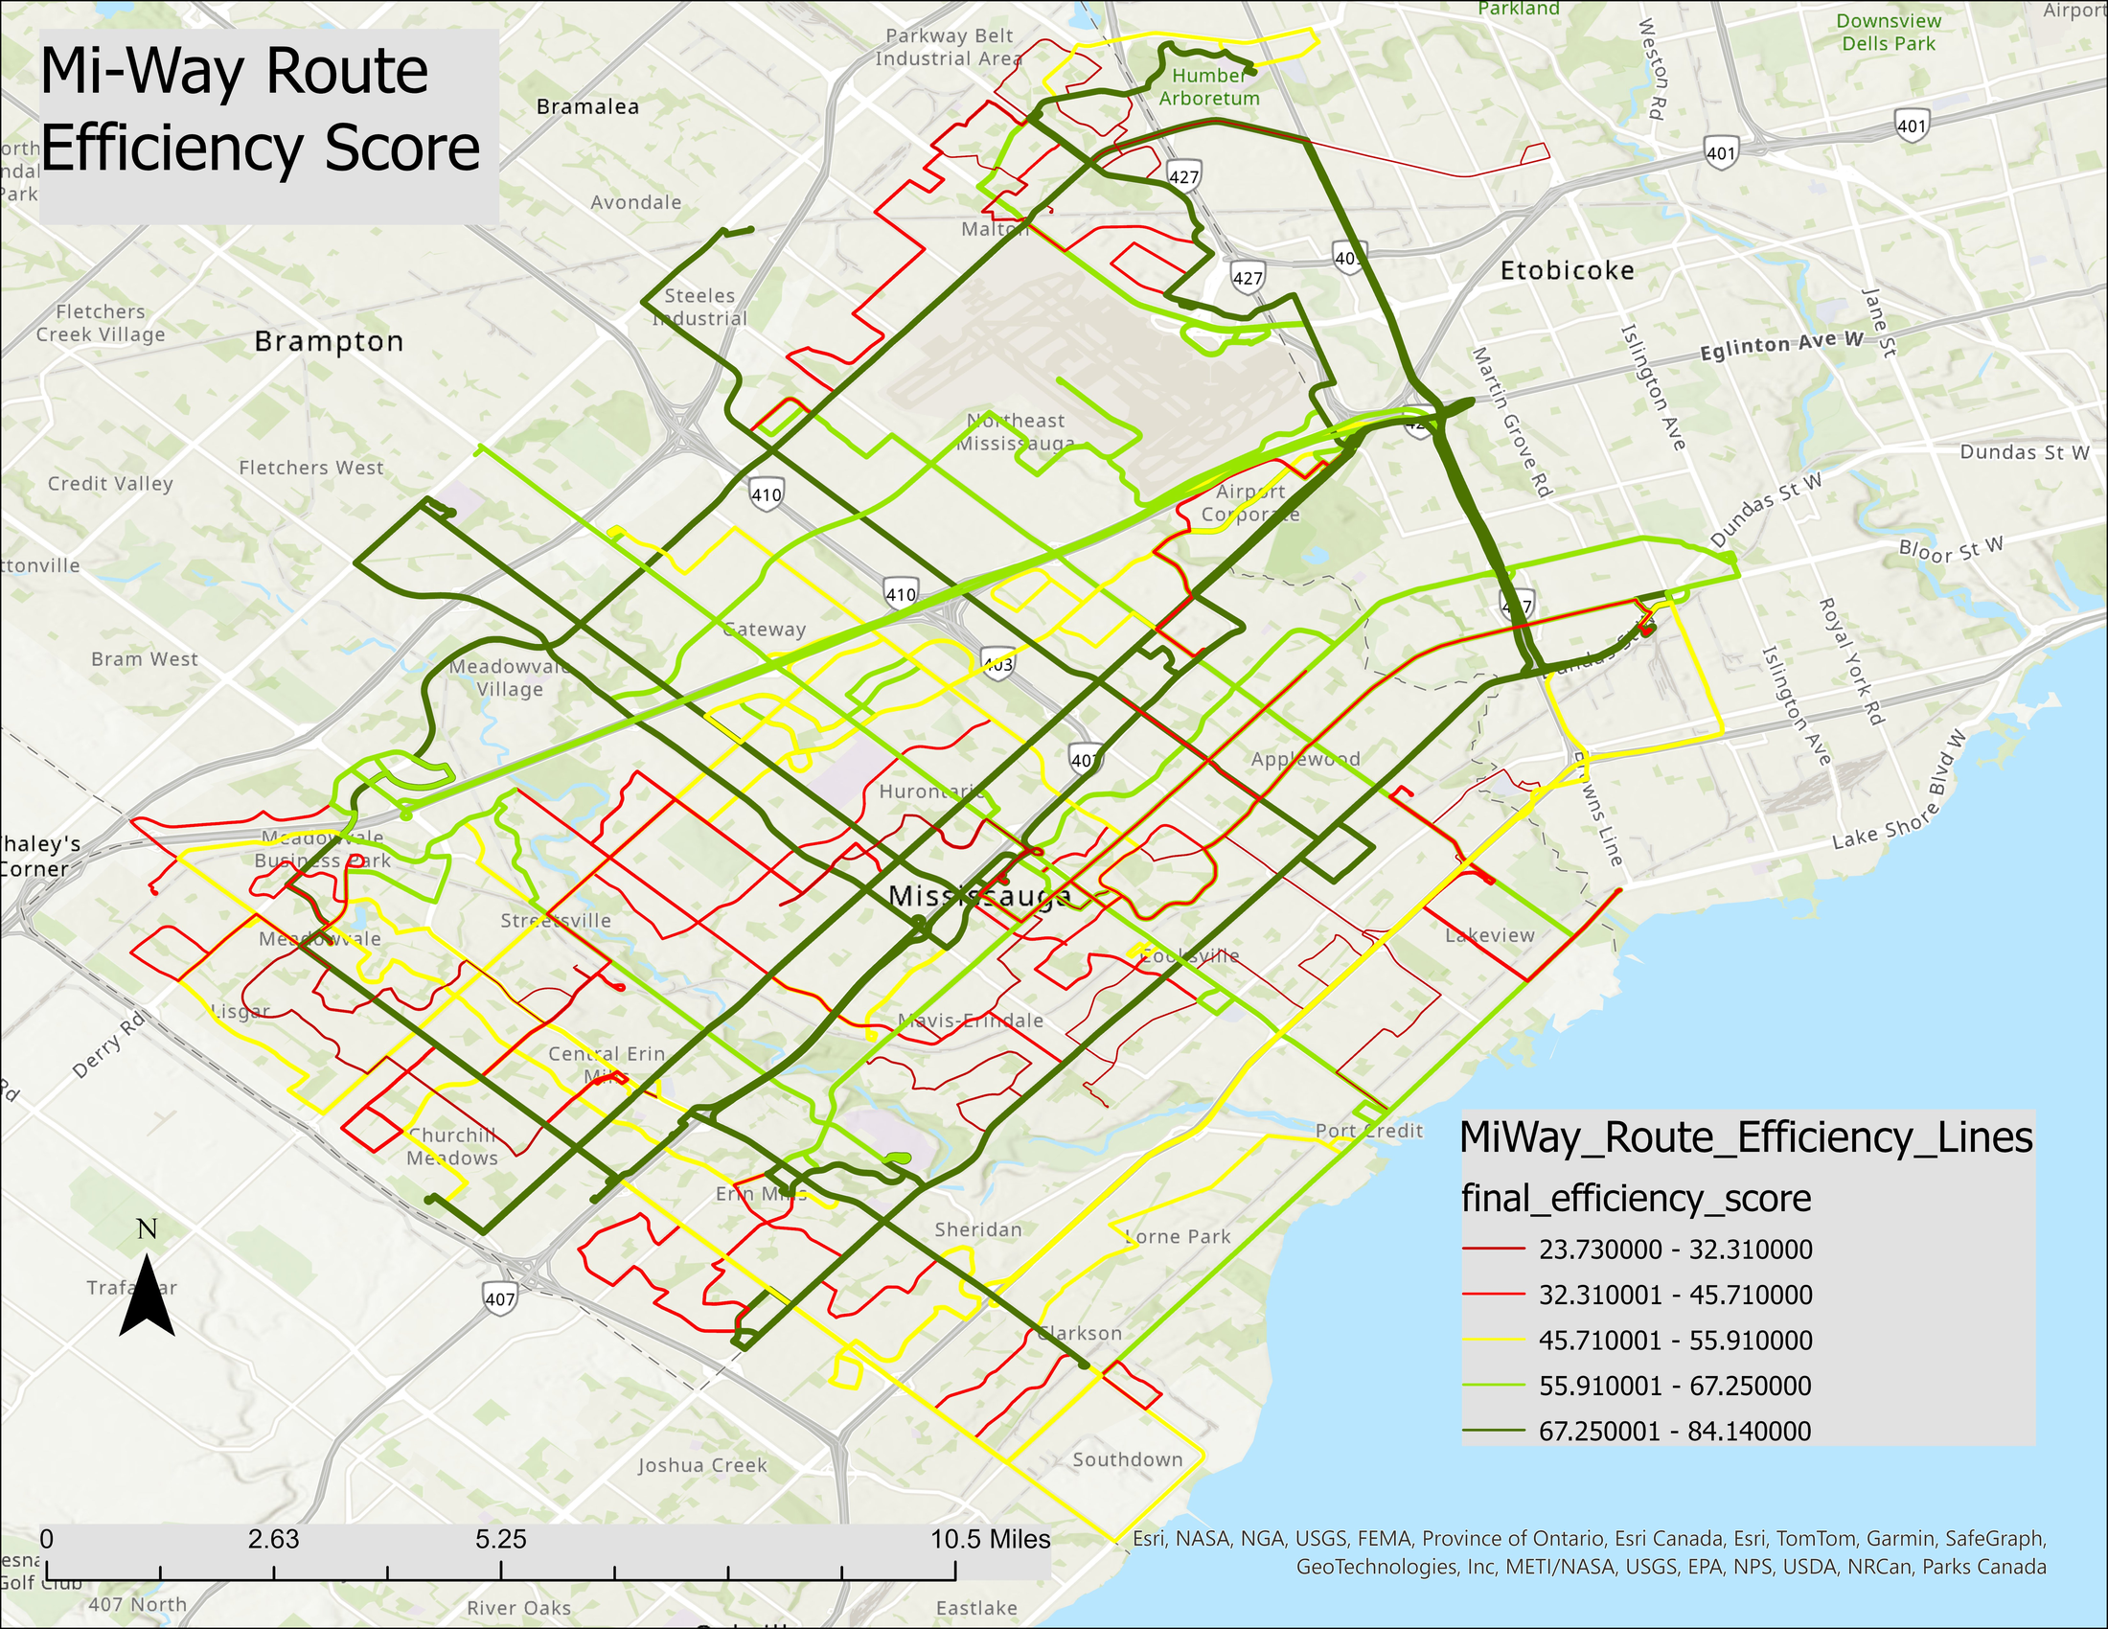
Source: MiWay GTFS scheduled service feed, May 2026. Analysis: MiWay Route Improvement Advocacy.

Figure 2 — Top 10 MiWay Advocacy Priority Routes
Routes ranked by advocacy priority score: 0.60 × improvement need + 0.40 × service importance
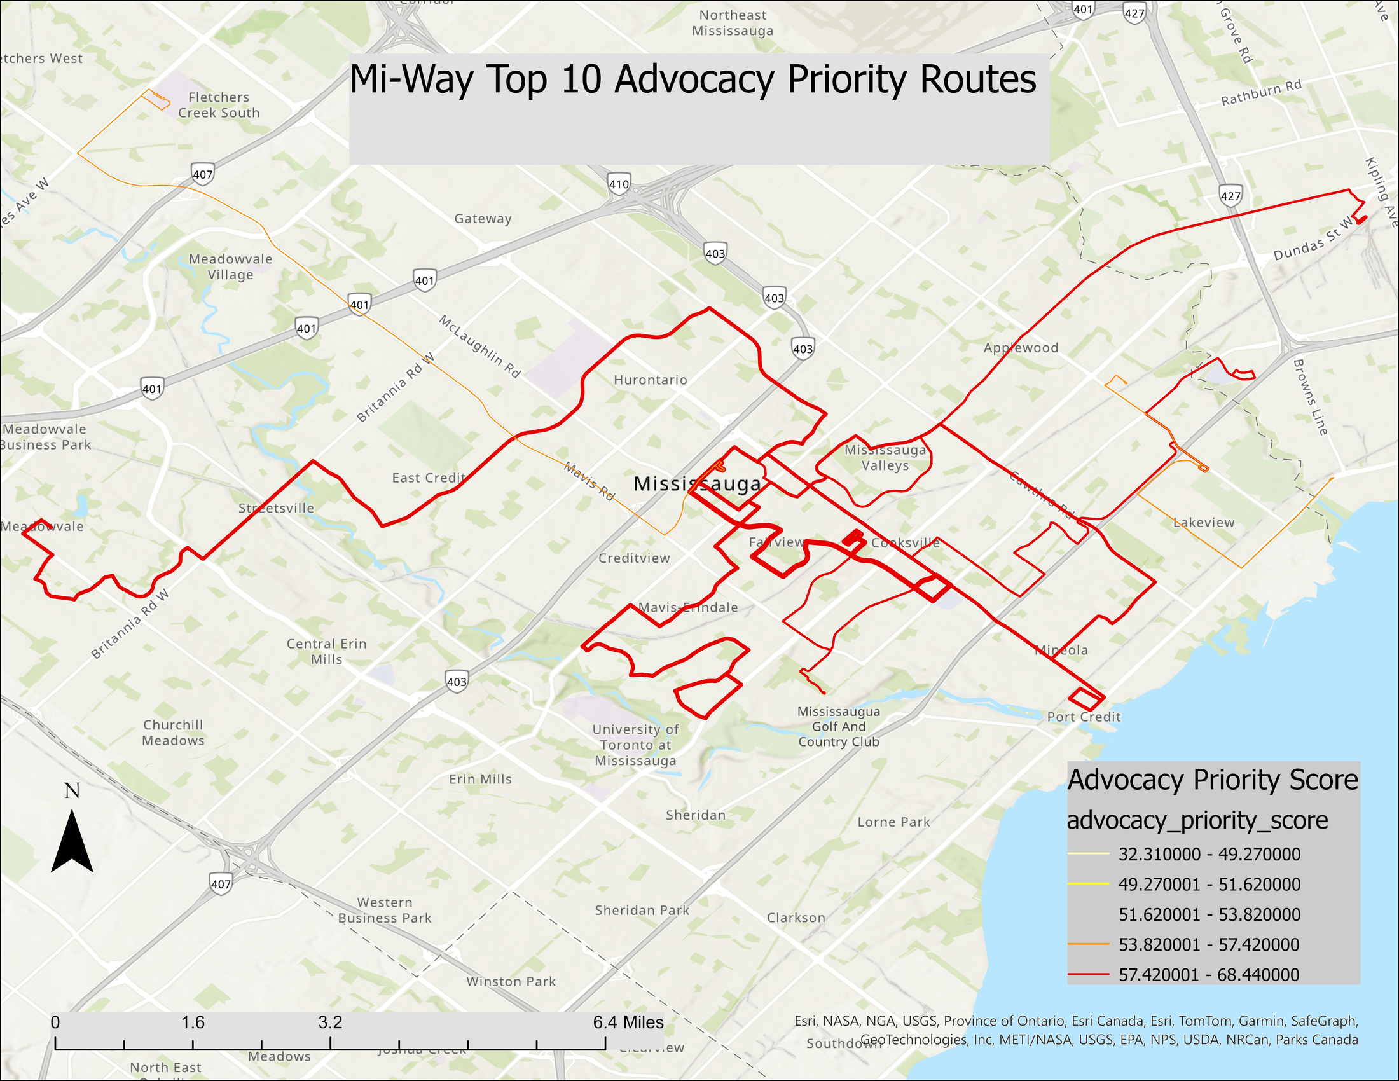
Source: MiWay GTFS scheduled service feed, May 2026. ArcGIS Pro layout export. Analysis: MiWay Route Improvement Advocacy.

Appendix A – Lower Scoring Routes
The routes below have the lowest final scores. Results should be interpreted with service purpose in mind. A school route, loop route, or coverage route may score low while still serving a valid equity or access function.
Rank | Route | Name | Score | Trips | Speed (km/h) | Headway (min)
66 | 321 | Stephen Lewis SS | 17.46 | 5 | 14.96 | 33.00
65 | 30 | Rexdale | 23.73 | 48 | 19.14 | 55.00
64 | 4 | North Service Road | 24.64 | 55 | 19.86 | 44.00
63 | 313 | Streetsville SS | 24.68 | 3 | 20.39 | n/a
62 | 8 | Cawthra | 26.33 | 71 | 18.60 | 35.00
61 | 16 | Malton | 27.34 | 50 | 19.34 | 40.00
60 | 6 | Credit Woodlands | 29.03 | 93 | 18.39 | 28.00
59 | 315 | Rick Hansen SS | 32.05 | 3 | 14.95 | 4.00
58 | 46 | Tenth Line | 32.31 | 62 | 19.73 | 44.00
57 | 304 | Father Goetz SS | 34.63 | 1 | 17.43 | n/a

Appendix B – Scoring Formula Reference
Frequency sub-score:
frequency_score = 0.70 × headway_score + 0.30 × trip_volume_score
Advocacy priority score:
advocacy_priority_score = 0.60 × (100 − final_efficiency_score) + 0.40 × service_importance_score
Final efficiency score:
final_efficiency_score = 0.25(speed) + 0.25(frequency) + 0.15(service span) + 0.15(directness) + 0.10(stop spacing) + 0.10(directional balance)
Percentile scoring:
Each raw metric is ranked against other MiWay routes. For higher-is-better metrics, higher percentile = higher score. For lower-is-better metrics (headway, stop density), the percentile is reversed: score = 101 − percentile rank. Missing values receive a neutral score of 50.

MiWay Route Efficiency Analysis — May 2026

